# Question and Model Prediction

Model Used: LXMERT  
Question Asked: How many cars are there?  
Prediction: 2

# Prediction Details

2 0.96731  
1 0.03206  
3 0.00055  
4 0.00004  
0 0.00002

# User Settings

Camera Effect:

# Original Image

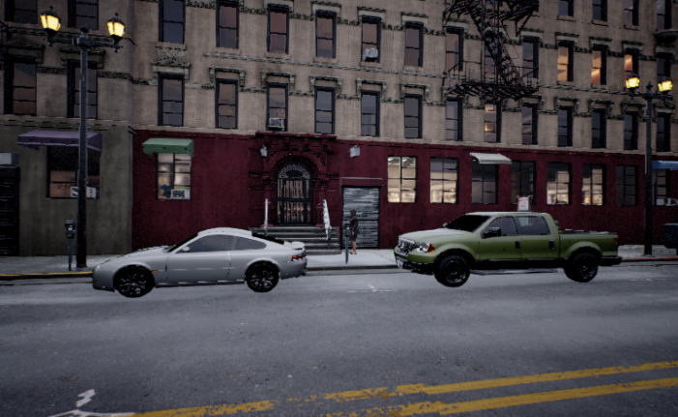

# Model Visualizations

## Faster RCNN Boxes.png

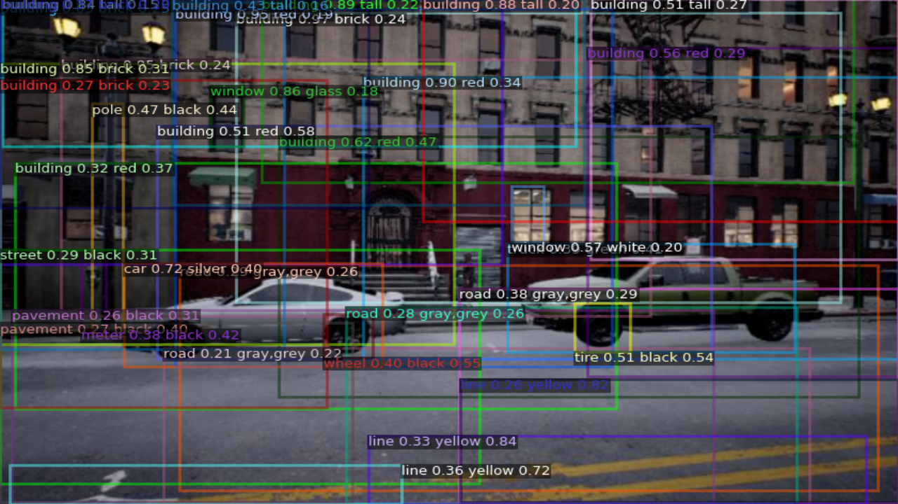

## Chefer Explainability.png

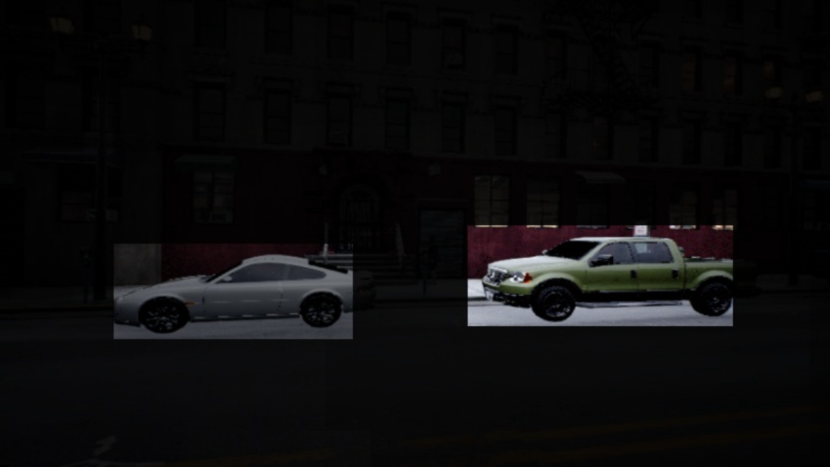

## Gradcam.png

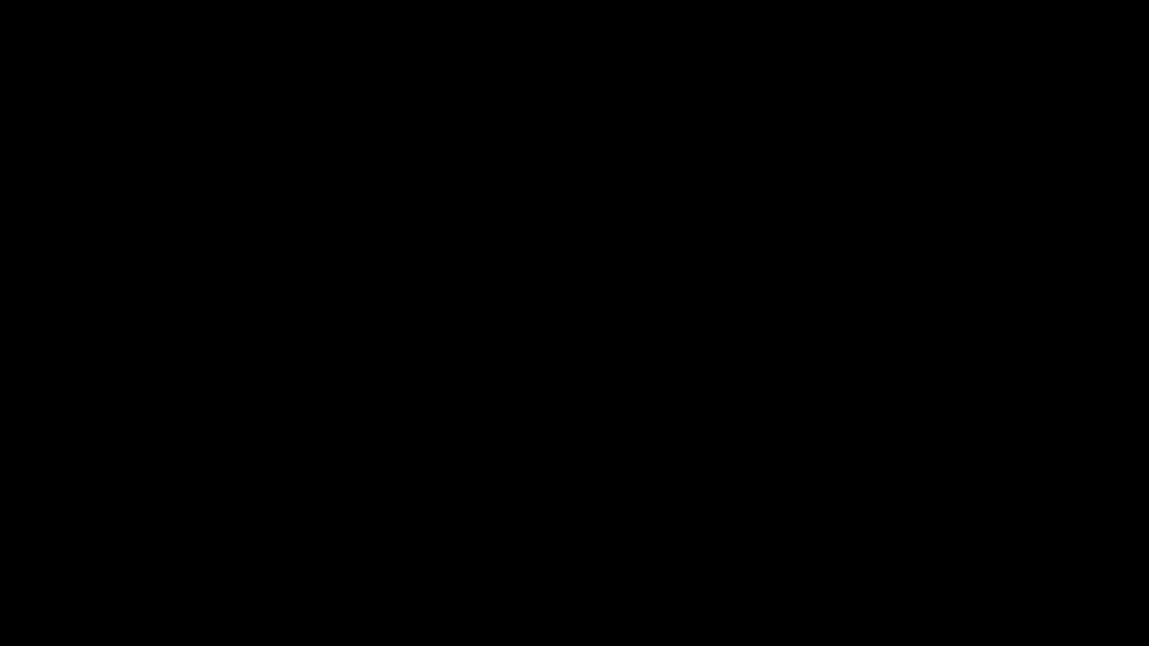

## Attention Rollout.png

